|  |
| --- |
| **National University of Computer and Emerging Sciences** |
| Lab Manual 1.2  “Java Script and CSS in ASP.net Web” |
|  |
| Database Systems |
| Spring 2023 |

Department of Computer Science

FAST-NU, Lahore, Pakistan

**Table of Contents**

1. Objective 2

2. Prerequisites 2

3. Task Distribution 2

4. CSS- Cascaded Style Sheet 3

Different Ways to Add Styles to Tags: 4

CSS-Selector 4

CSS-ID and CSS-CLASS 5

CSS-ID 5

CSS-CLASS 5

CSS EXERCISE 7

SELF EXPLORATION: 7

5. JAVA SCRIPT 8

Java Script EXERCISE 10

SELF EXPLORATION: 10

# Objective

In this lab you will learn how to use CSS to style ASP.net web application an How to use JavaScript to perform client side validation.

# Prerequisites

* Lab 1 manual, Introduction to Asp.net.
* Slides of JavaScript
* Slides on HTML and CSS (although these slides are on how to use CSS in HTML, they will be useful in ASP.net web forms as well.)

# Task Distribution

|  |  |
| --- | --- |
| Total Time | 90 Minutes |
| CSS | 10 Minutes |
| JavaScript | 20 Minutes |
| Exercise | 50 Minutes |

# CSS- Cascaded Style Sheet

CSS is a language used to design and style the layout of web page, including colors, size, images font etc. To use CSS you first create a Style and then you can apply it to Tags (for examples on button tag, textbox tag etc).

TRY THIS:

Open Visual Studio, and create ASP.net web project then go to Solution Explorer and Add new ASPX web from.

Modify your Web form as follow: Add some text in body and add the CSS style tags as shown.

**NOTE DON’T CREATE ASP.net Empty Project, always create ASP.net web project

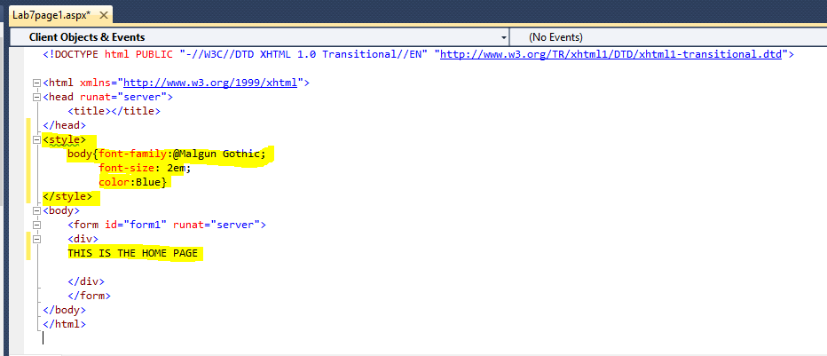

Execute your project (CTRL+F5) and make sure you open your own Web form in browser (see the URL in browser). Your web page will look as shown in figure, all the font in body tag will be of the style-rule **body** you defined in Style tag.

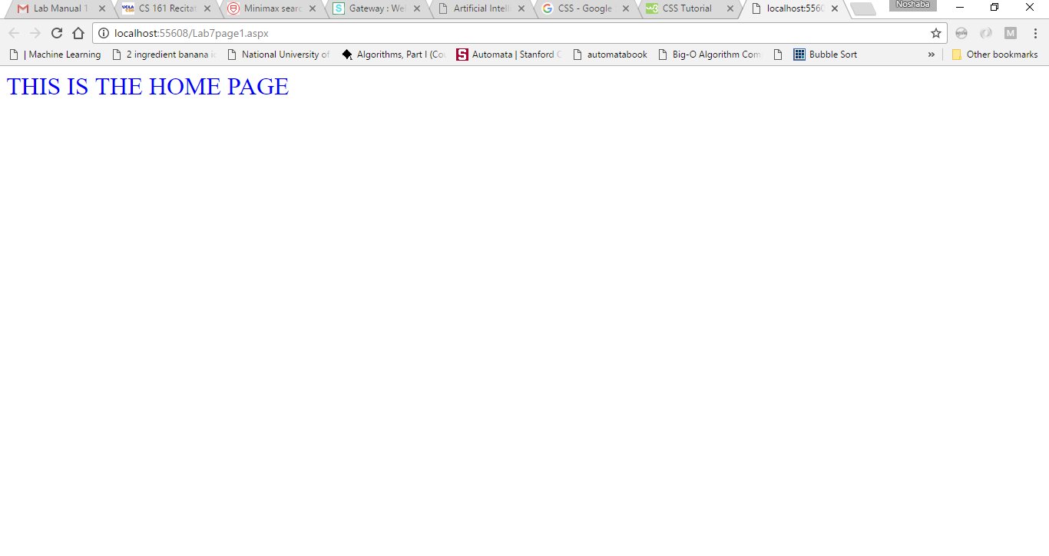

## Different Ways to Add Styles to Tags:

### CSS-Selector

The above example defined a style on **body tag**. This is called CSS selector. The selector points to the Asp.net element you want to style. Syntax to define CSS-Selector Style rules is



Selectors can be any HTML elements such as h1 tag, p tag, body tag.

TRY IT: Add h1 tags to you Web form and then add the following CSS selector to Style tag.

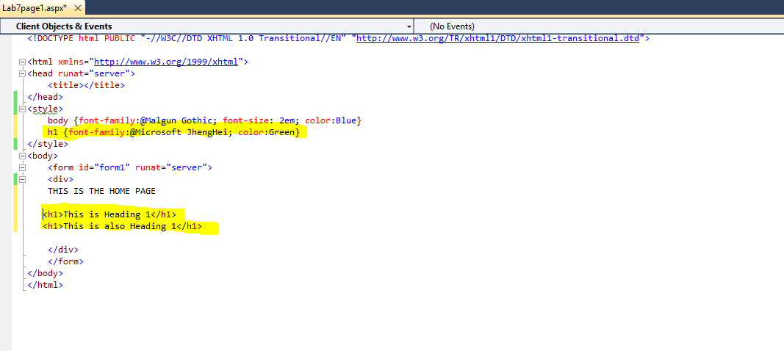

Execute, all the text in h1 tag will have the Style h1 selector.

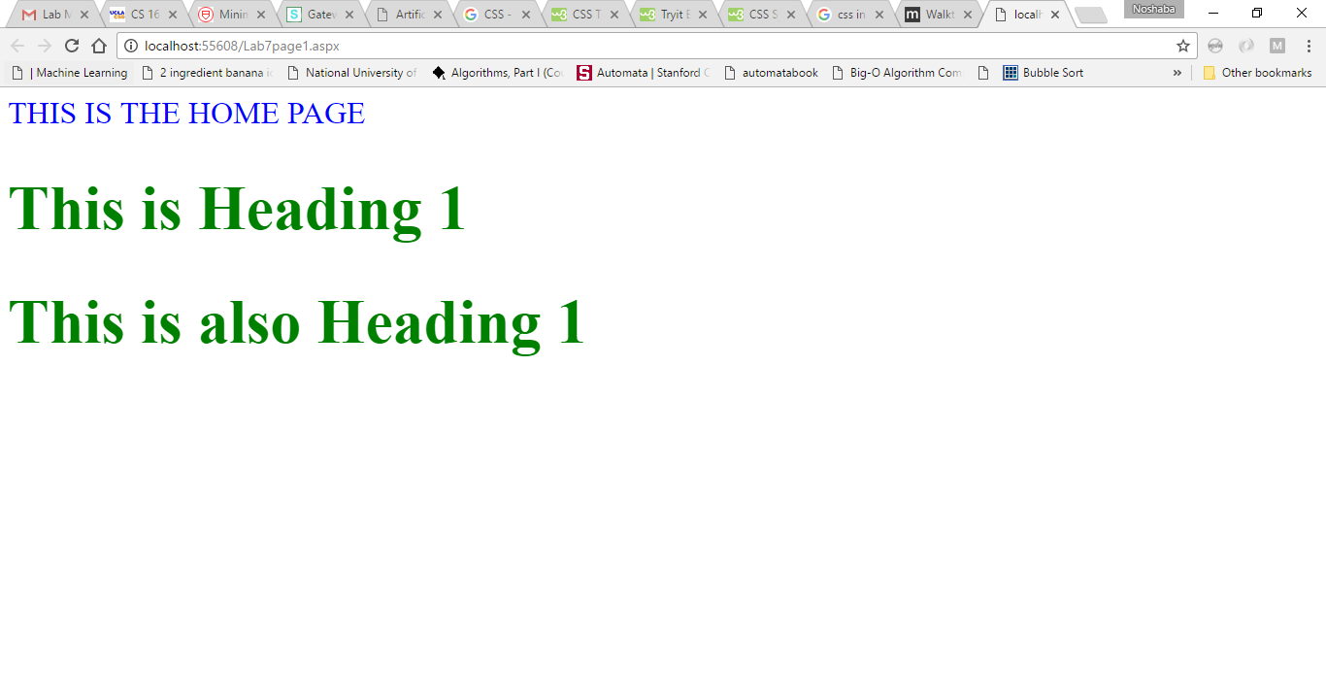

## CSS-ID and CSS-CLASS

To change the style of ASP.net controls such as buttons and textboxes, you can use CSS-ID or CSS-CLASS.

### CSS-**ID**

CSS-ID is used to change the style of only one specifc ASP.net control in Web form.

CSS-ID is defined as follow:

#ClassName {Property:Value; Property:Value; Property:Value}

Example:



Now the ASP.net control with ID=submit will be styled according to the #submit rules, and as all controls have unique ID CSS-ID rules can only be for once control on one page.

### CSS-CLASS

Unlike CSS-ID, CSS-Class can be used for more than one control (same or different type) in a page. To apply CSS-class to ASP.net control set the CssClass property of that control equal to that CSS-Class

CSS class is defined as follow:

.ClassName {Property:Value; Property:Value; Property:Value}

Example:



NOTE: Classname will always begin with a dot <.>, List of property:value is separated by semicolon <;>

TRY THIS: Add .buttonCSS style to Style tag, add two buttons in you page and set there CssClass="buttonCSS", as shown in figure. Also add #submit style to you Style tag and add one button with ID="submit"

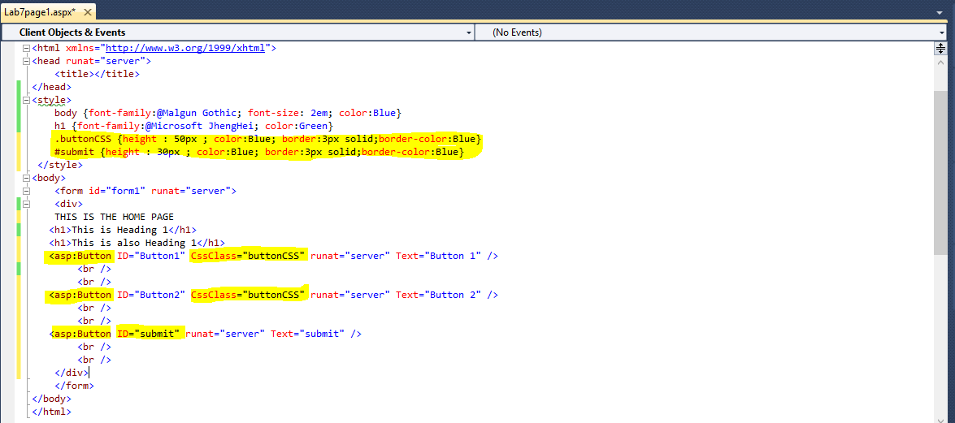

Execute it,

Button 1 and Button 2 has .buttonCSS rules applied on it to it and Submit has #submit style applied to it.

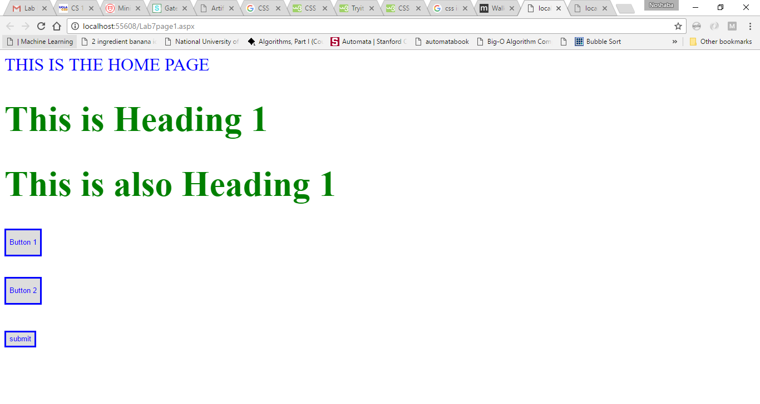

## CSS EXERCISE

Create new Web form as shown in figure below and Replicate the following:

* Main Heading style and color.
* All the other text style and color.
* Button’s text color and border color and border glow, buttons also have round edges.
* Text box border color and glow.
* Drop down border color and glow, it has three options, Dollar, Euro and Pound
* Search the property and values to do these from imternet.

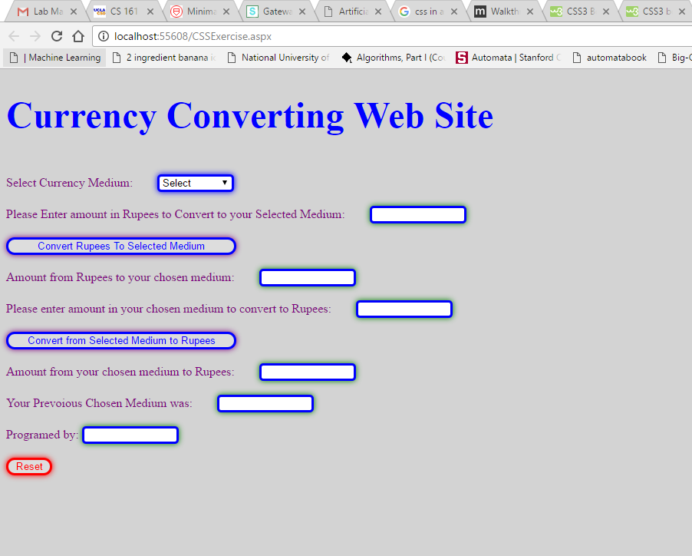

### SELF EXPLORATION:

You can also separate CSS style from Web from by adding Style in .CSS file and link it to your Web form.

# JAVA SCRIPT

JavaScript is the most popular scripting language on the internet. JavaScript is used in millions of Web pages to improve the design, validate forms, detect browsers, create cookies, and much more. It works in all major browsers, such as Internet Explorer, Mozilla, Firefox, Netscape, Opera.

In this manual we will use jave Script to perform Client side operations or validation.

TRY THIS:

Create a new Web form and add Script tag and add statments to it as shown in figure. The statment in the script will run when run when ever the page is loaded.

document.write(String) *will overwrite your web page and display the string you give it as input*

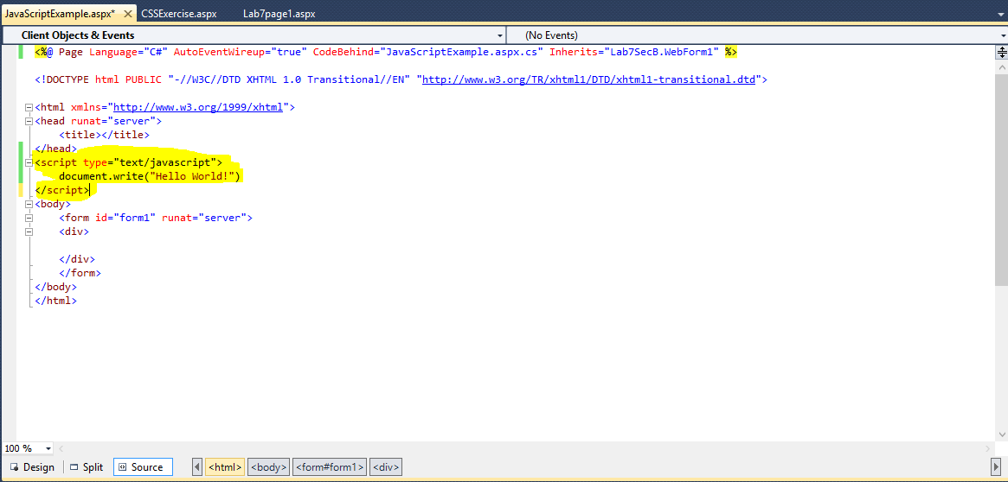

Execute your page and result should be as follow:

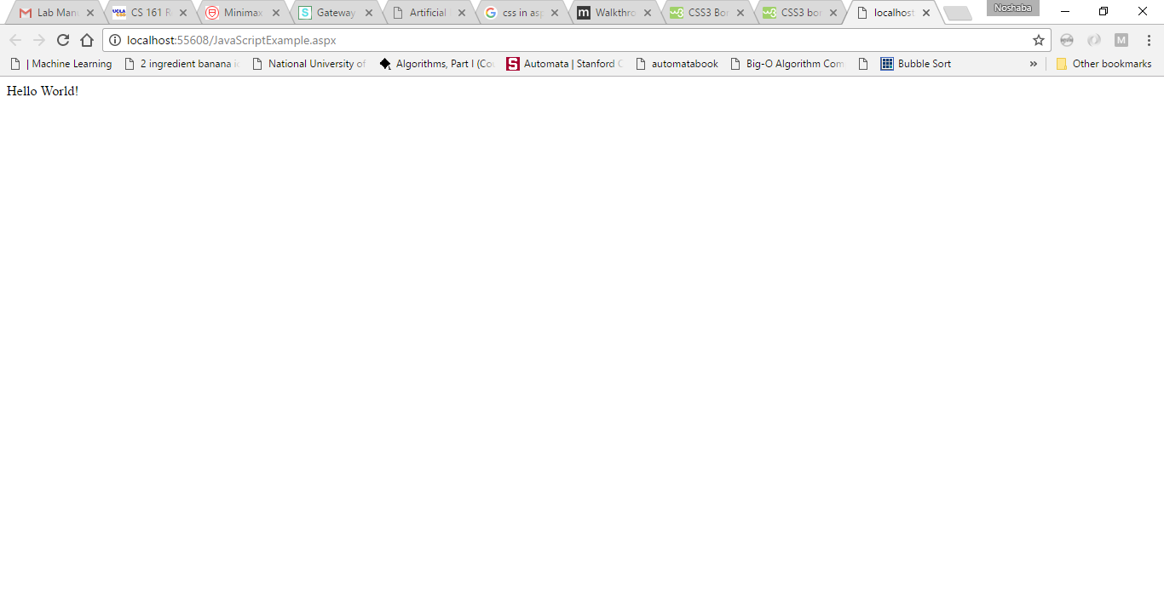

You can create functions in java script that can be called on some specific action:

Syntax of Javascript function is

function <fucntionName>()

{

<body>

}

TRY THIS

Create a page as shown, the page will take two numbers and when you press the button JavasScript function AddTwoNumbers will be called this function will add the two numbers and display in output textbox.

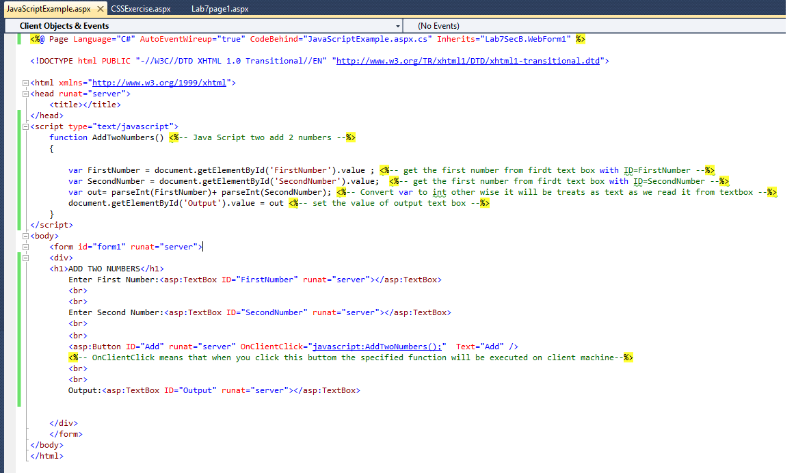

The example showed how to take get input from text boxes in javascript function, how to set value of text box in JavaScript function, and how to specify what function should be called on Client side when a button is pressed

## Java Script EXERCISE

Use the Web form you create and how create Java Script function to convert currency to/from Rs to selected medium

* Create a JS function that will be called when ‘Convert to RS from selected Medium’ is pressed, it should get the value from 1st text box and convert it to selected medium, and display in 2nd text boc
* Create a JS function the will be called when Selected medium to Rs is clicked, it should take value from 3rd text box convert it into Rs from selected currency and display in 4th text box
* Create a JS function that will be called when Reset button is pressed, it should clear all the text boxes, display the selected currency in 5th text box and you name and roll number in 6th text box.

**NOTE: DON’T USE KEYWORDS SUCH AS RESET AS NAME OF YOU JS FUNCTIONS



### SELF EXPLORATION:

You can also separate CSS style from Web from by adding Style in .CSS file and link it to your Web form.

